

Department of Computer Science and Engineering
Islamic University of Technology (IUT)
A subsidiary organ of OIC

Laboratory Report

CSE 4512: Computer Networks Lab

Name:Md Abdullah Al Jubaer Gem
Student ID:210041226
Section:2B
Semester:5th
Academic Year:2023-2024

Date of Submission:10-06-2024

Title: VLAN configuration and Inter-VLAN routing.

Objective:
- Define and describe the concept of VLAN
- Describe the advantages of VLAN
- Design and implement VLAN and inter-VLAN routing

Devices/ Software Used:
      - Cisco Packet Tracer

Theory:

VLAN Definition:
VLAN or Virtual LAN (Local Area Network) is a logical grouping of networking devices. When we create VLAN, we actually break a large broadcast domain into smaller broadcast domains. Consider VLAN as a subnet. Just as two different subnets cannot communicate with each other without a router, different VLANs also require a router to communicate

Usage of VLAN:
Imagine a company with three departments: HR, Finance, and IT. Each department needs to communicate with devices within its own department but should be isolated from others for security and performance reasons. Here’s how VLANs can help:
- Network Segmentation: The IT department has its own VLAN (VLAN 10), the Finance department is on VLAN 20, and the HR department is on VLAN 30. This means that even though all departments share the same physical network, their traffic is logically separated.
- Improved Security: If an employee in the HR department tries to access resources in the Finance department, the VLAN configuration can prevent that unauthorized access, enhancing security.
- Efficient Resource Management: By segmenting the network, the company ensures that HR’s video conferencing traffic won’t interfere with the Finance department's high-priority financial transactions, helping ensure smoother operations for both departments.
- Simplified Administration: If the company expands to a new office, the IT department can assign the new devices to VLAN 10 without physically altering the network setup. VLANs make it easier to manage devices and traffic across multiple locations.

Inter VLAN Routing:
VLAN Configuration: VLANs (e.g., VLAN 10 for HR, VLAN 20 for Finance) are created on the switch, and ports are assigned to the respective VLANs.
Router or Layer 3 Switch Setup: A router or Layer 3 switch is configured with subinterfaces or SVIs for each VLAN (e.g., 192.168.10.1 for VLAN 10, 192.168.20.1 for VLAN 20).
Default Gateways Set: Default gateways are configured on devices in each VLAN to point to the IP address of the router’s subinterface for that VLAN.
Routing Process: When a device in VLAN 10 wants to communicate with VLAN 20, the packet is sent to the router, where it is routed and forwarded to the destination device in VLAN 20.

Diagram of the experiment:
Task #01:
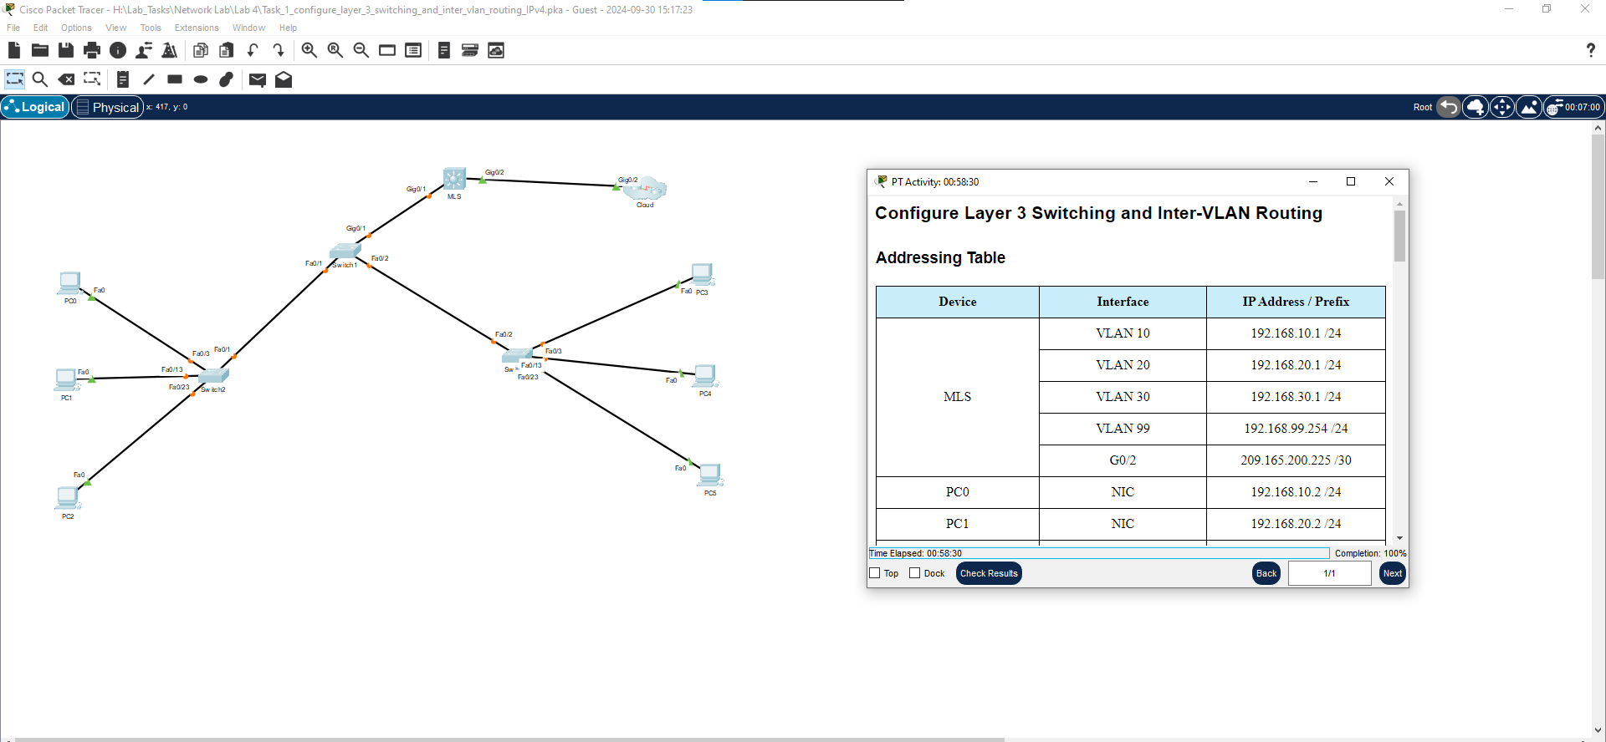
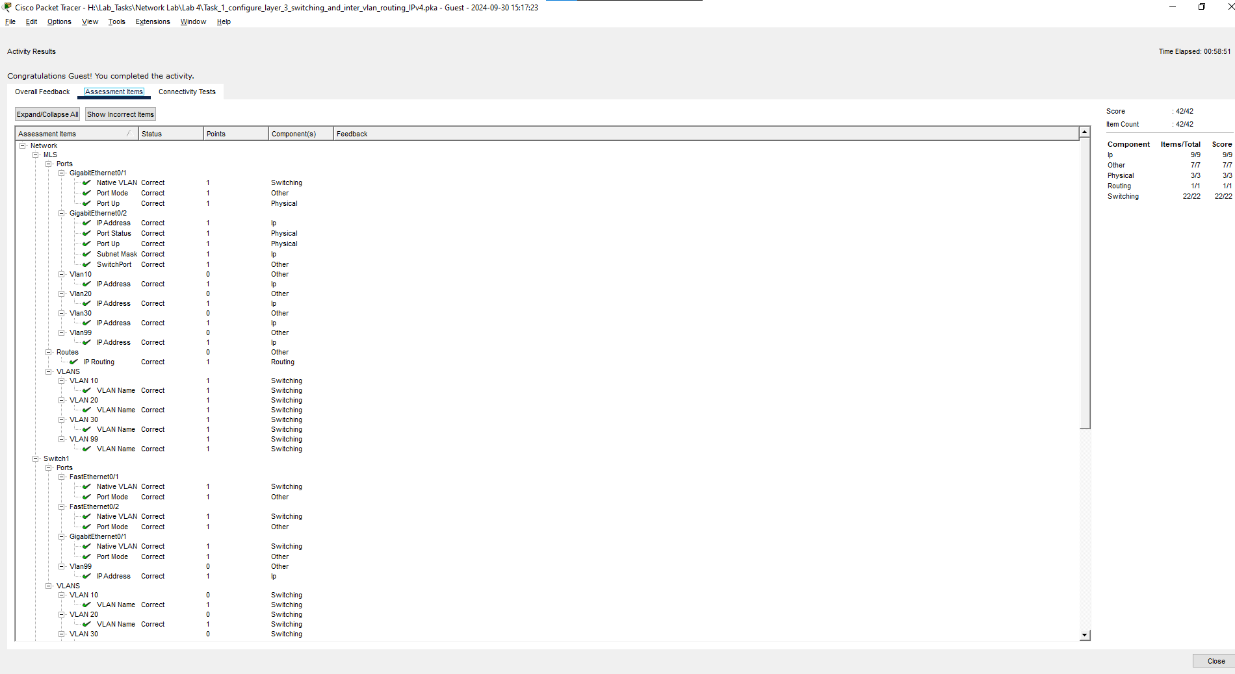

Task #02:
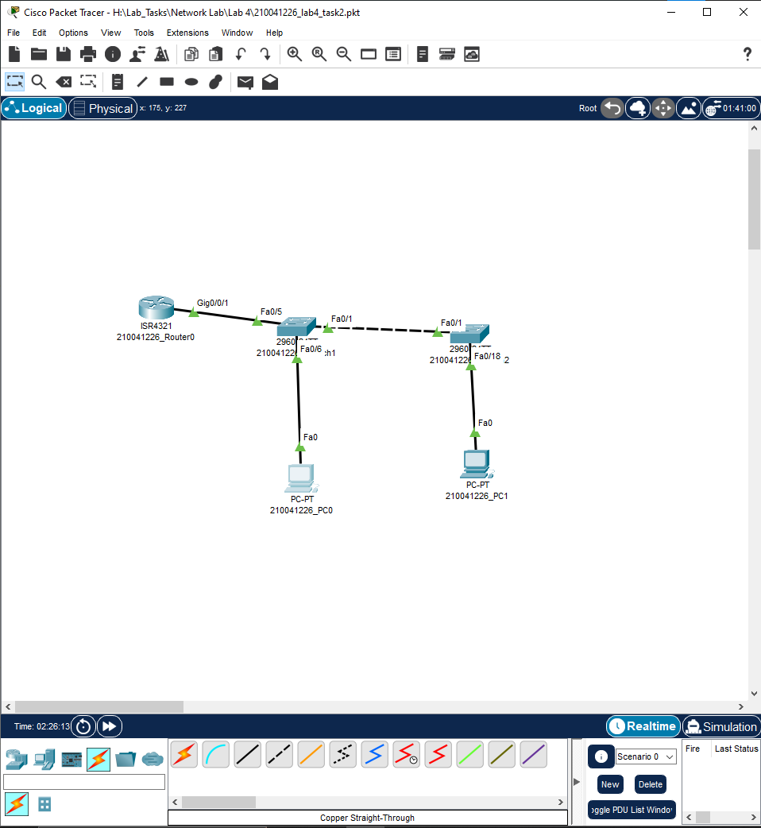

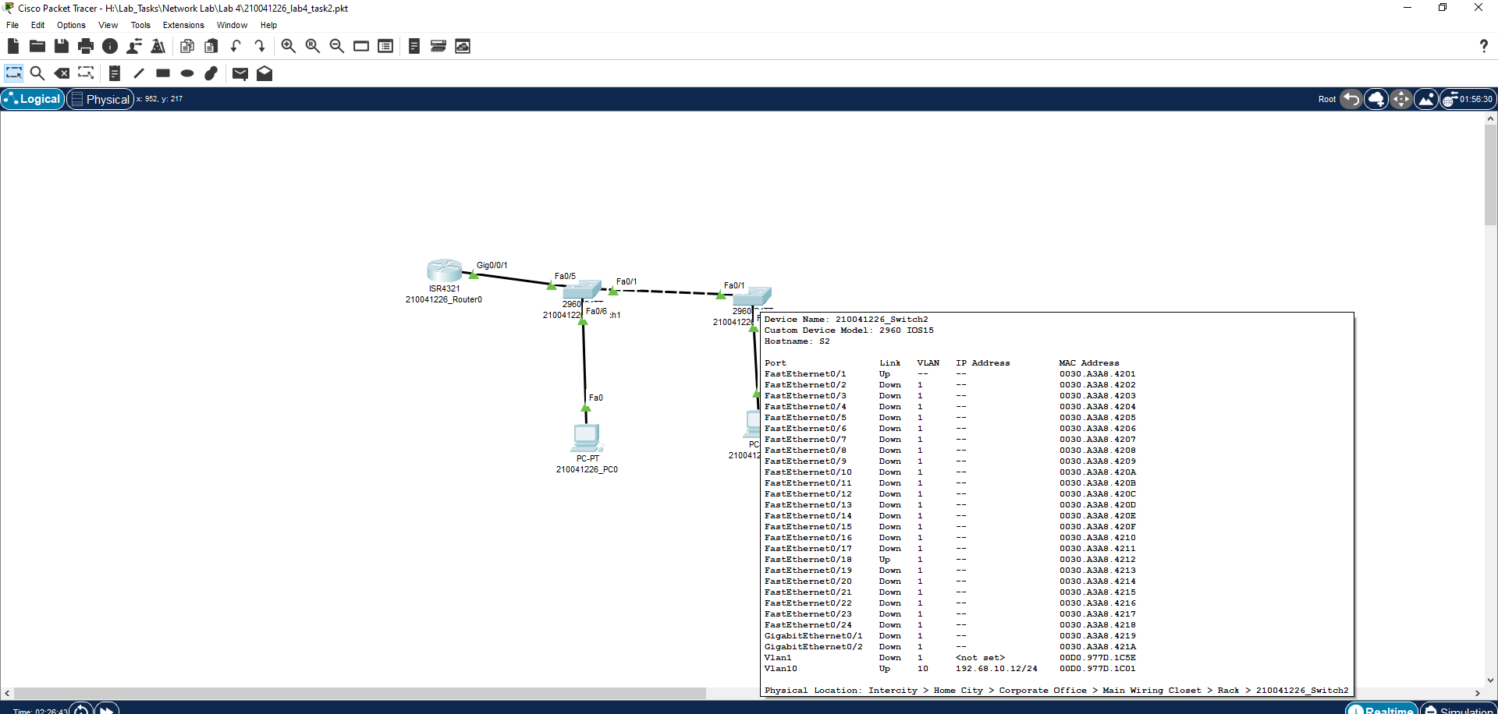
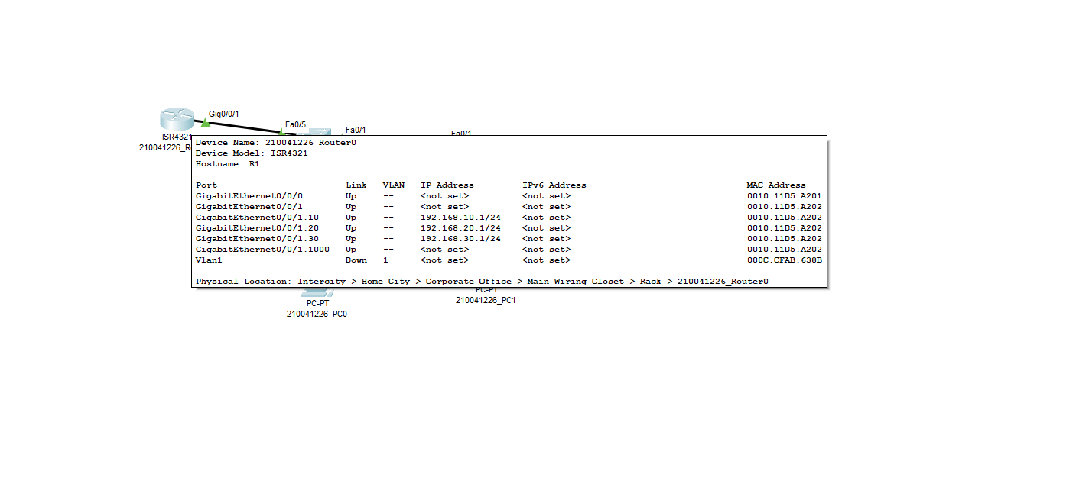

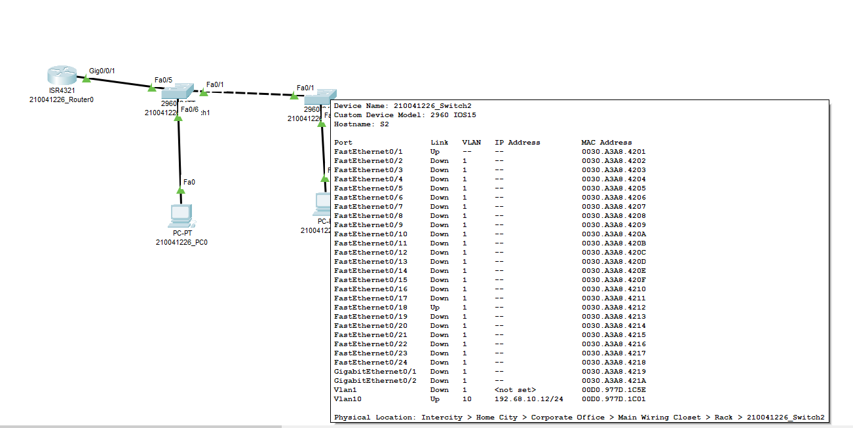
Task #03:
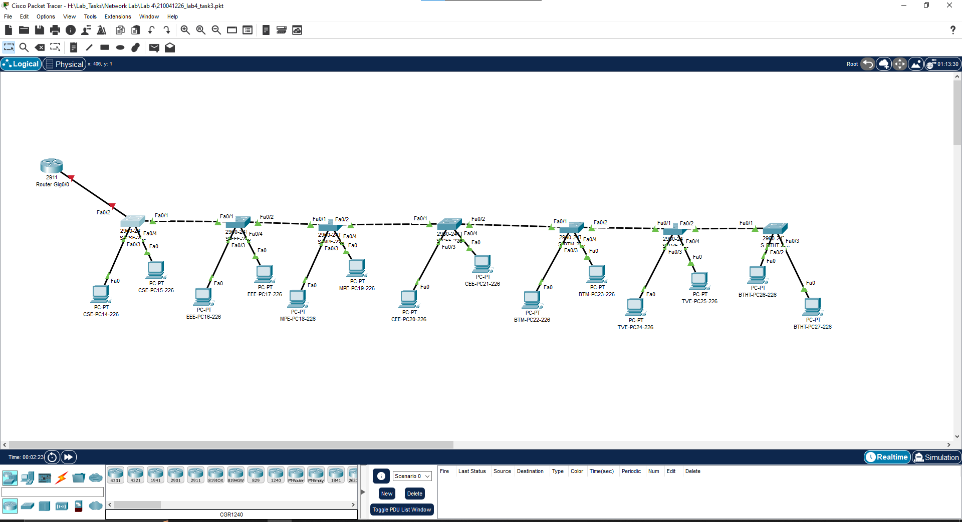
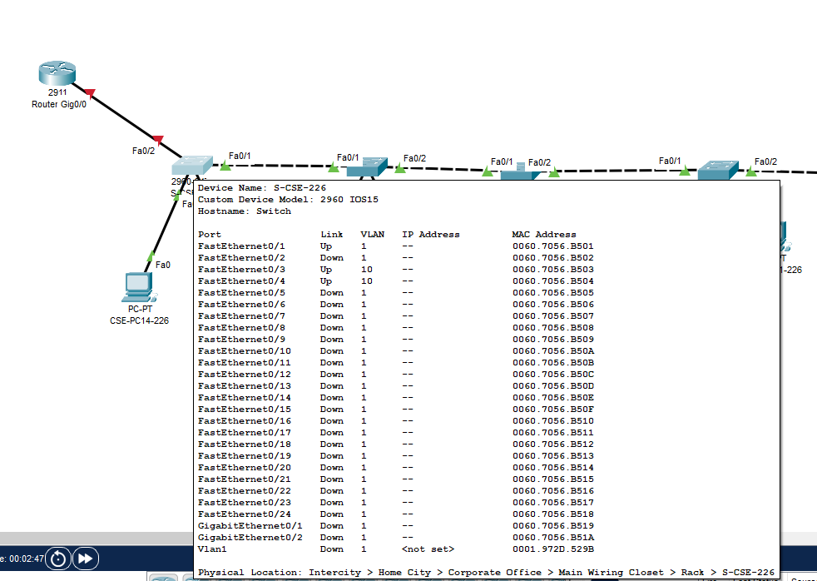
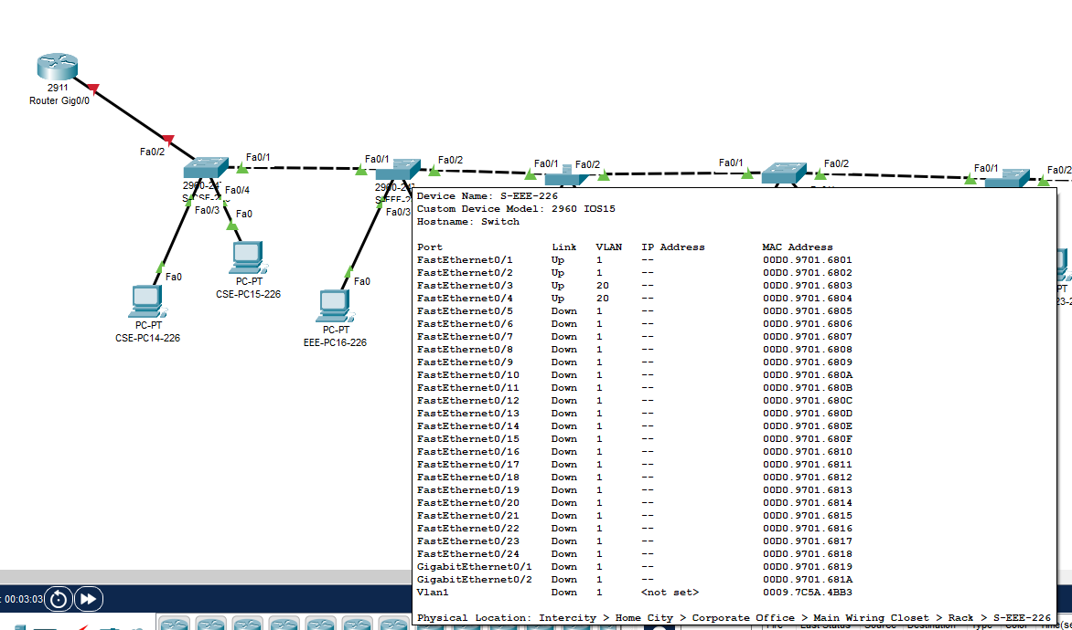
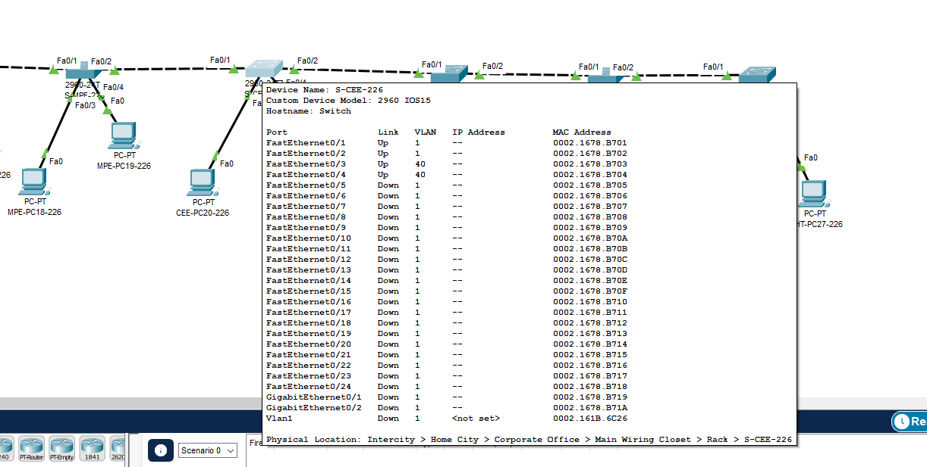

Working Procedure:
TASK #01:
- First the MLS Configuration
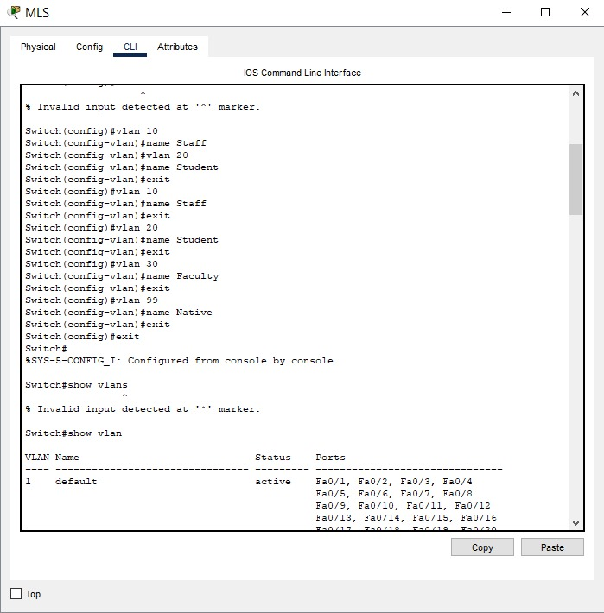
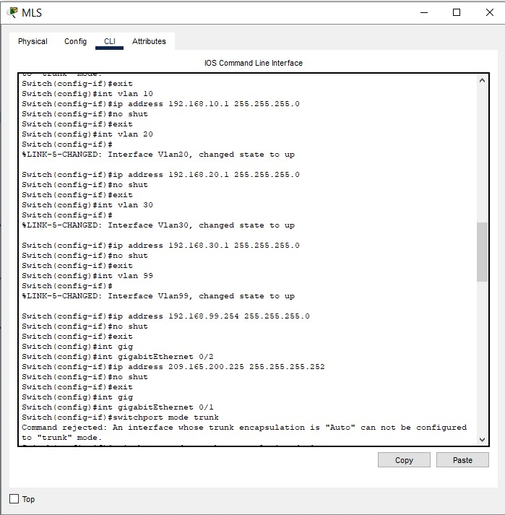
- Switch 1 Configuration
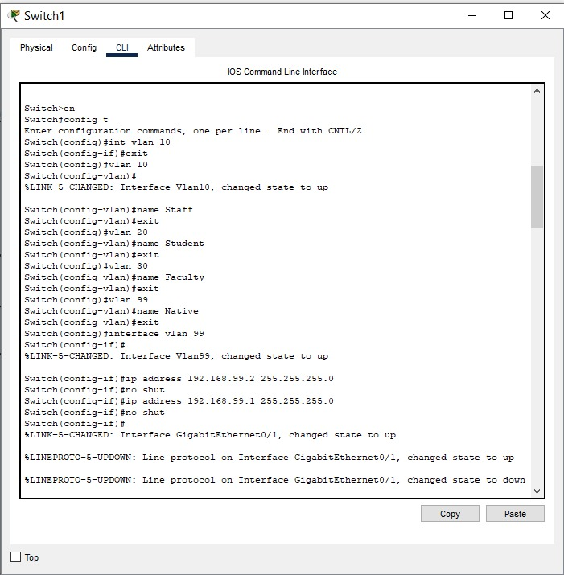
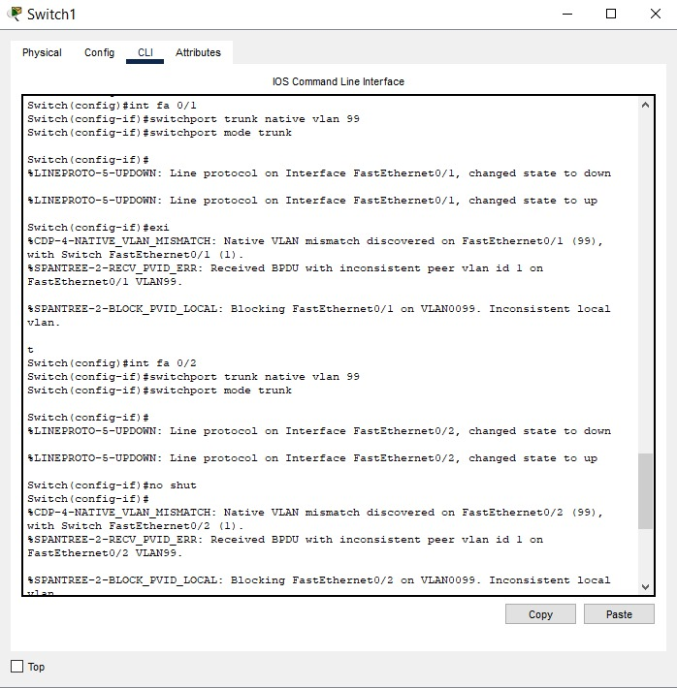

- Switch 2 Configuration
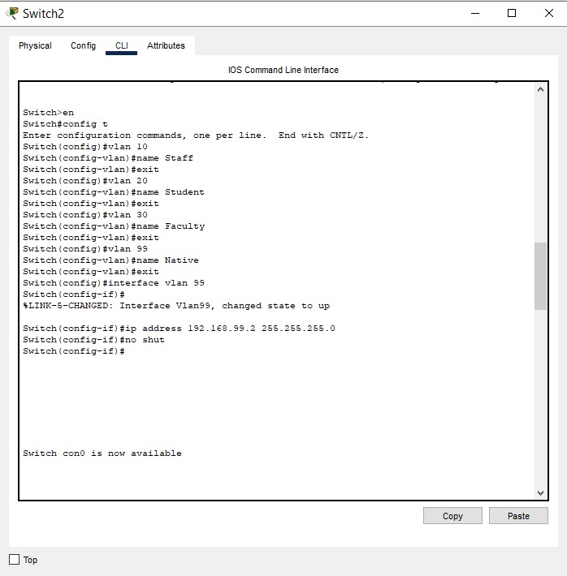
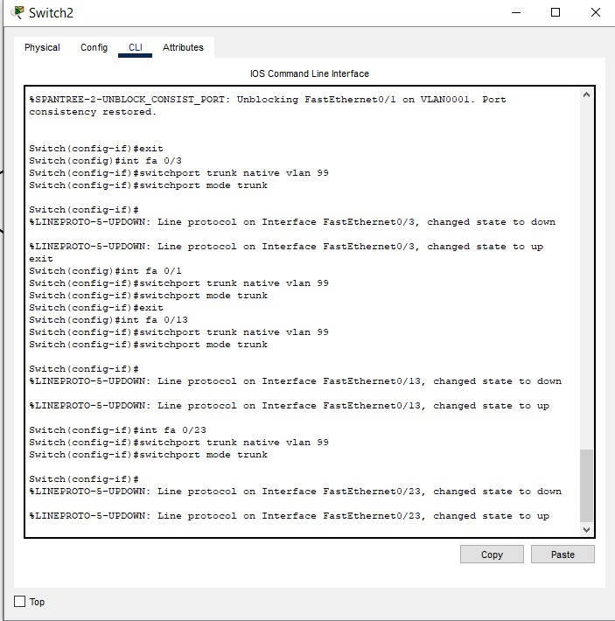
- Switch 3 Configuration
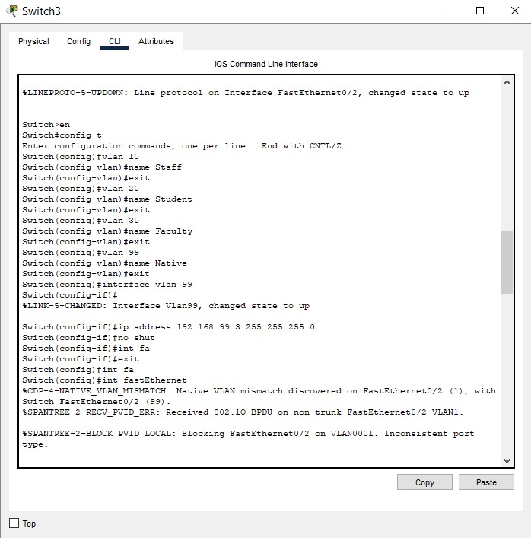
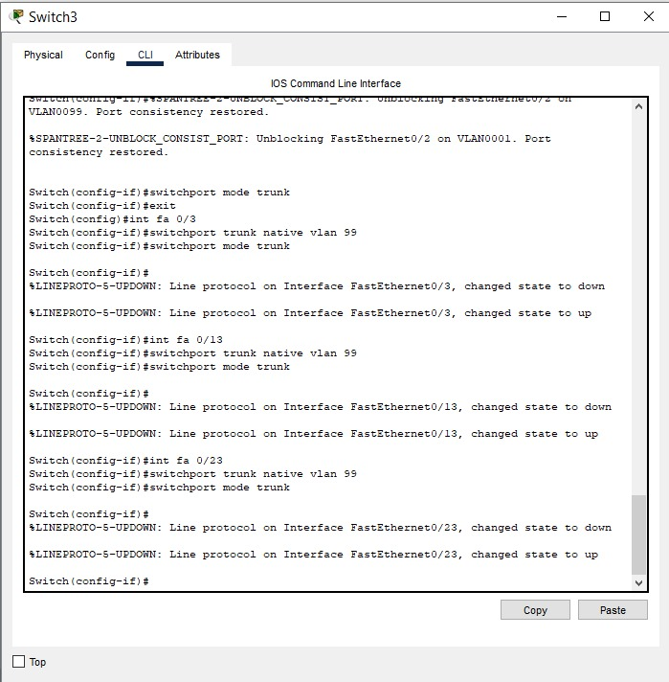
- Result
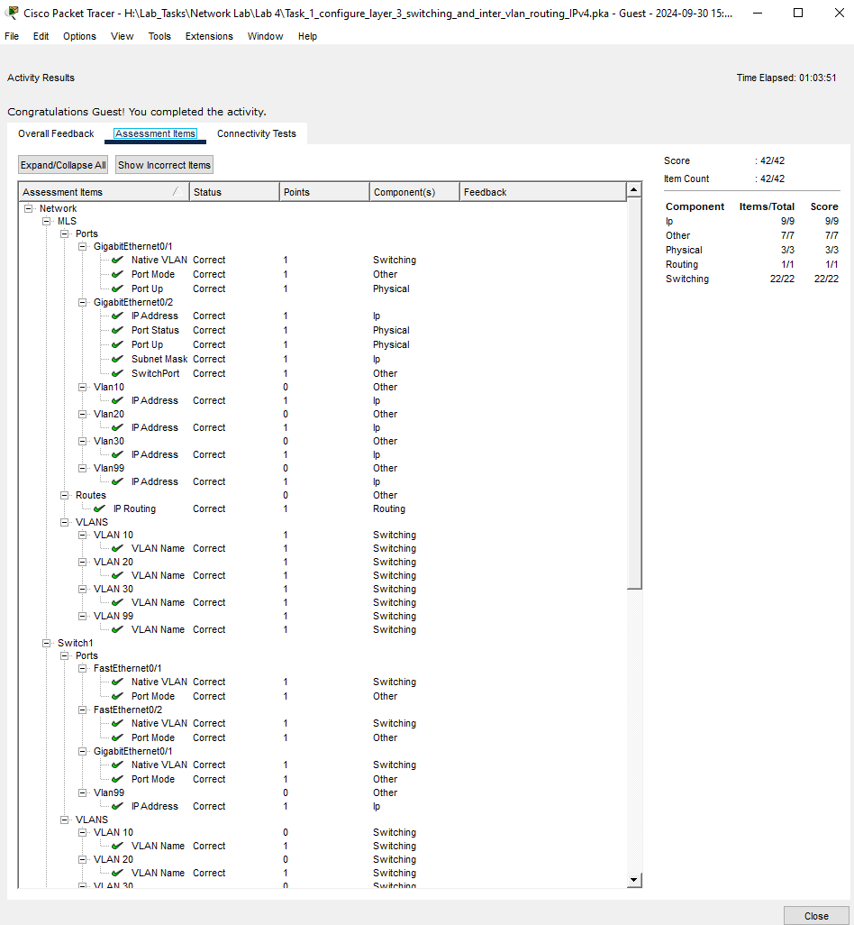

TASK #02:
- Router0 Configuration
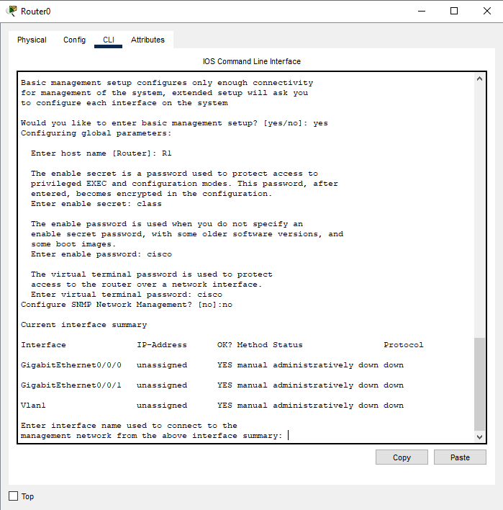
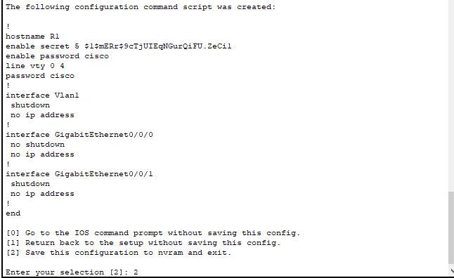

- Both Switches Configuration
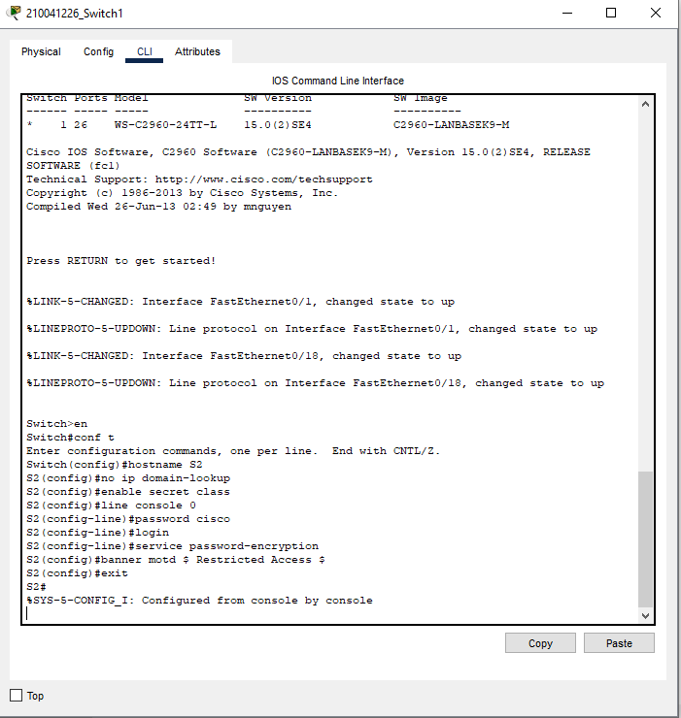
- Switch 1 Vlan Configuration
- 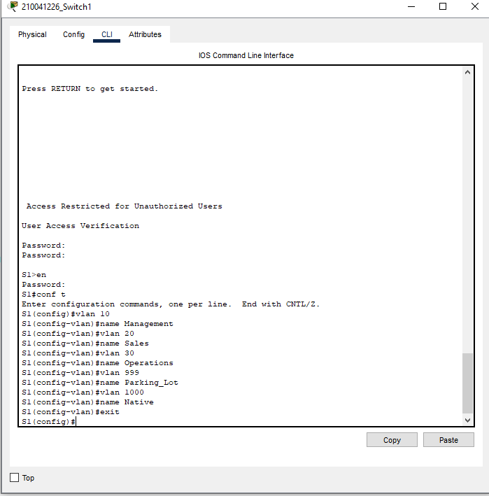

- Switch 2 Vlan Configuration
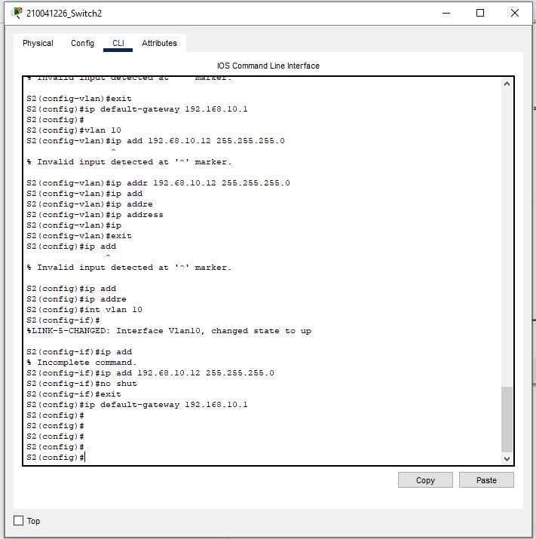

- Vlan 999 for Switch 1
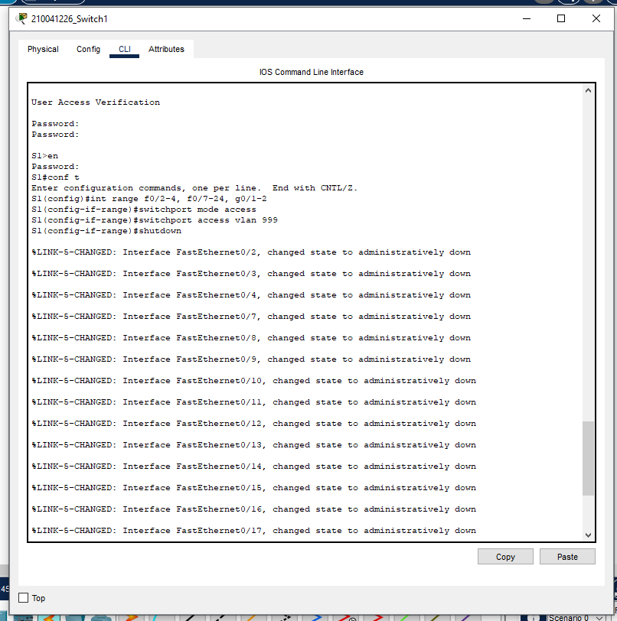
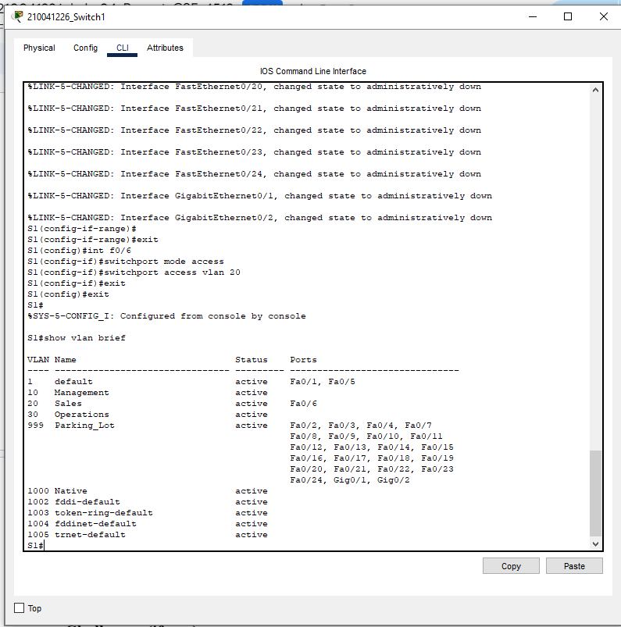

- Switch 2 Vlan Configuration
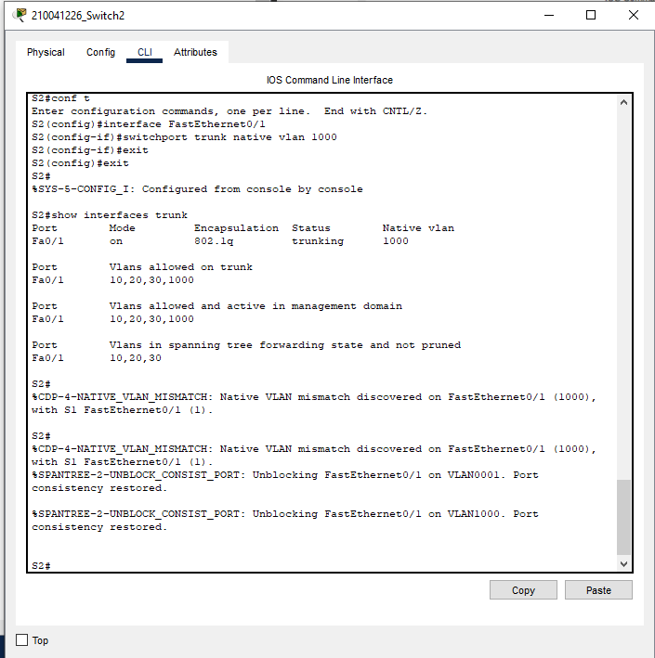
- Switch 1 Vlan Configuration
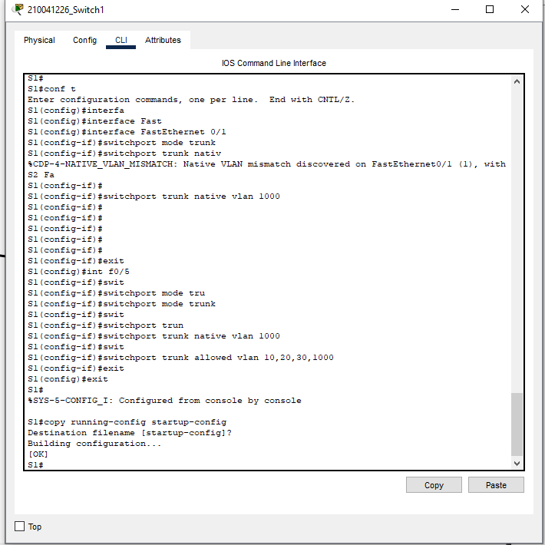

- Router0 Vlan Configuration
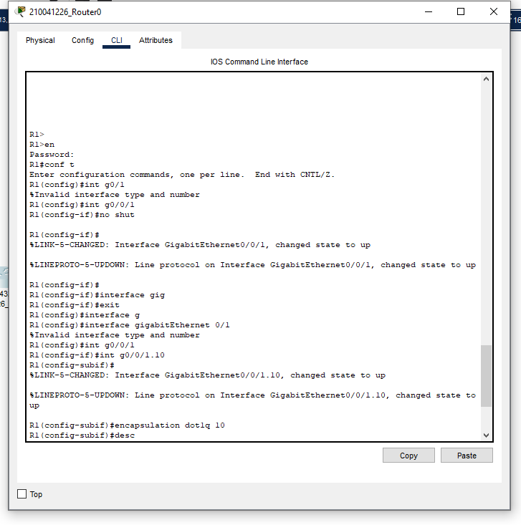

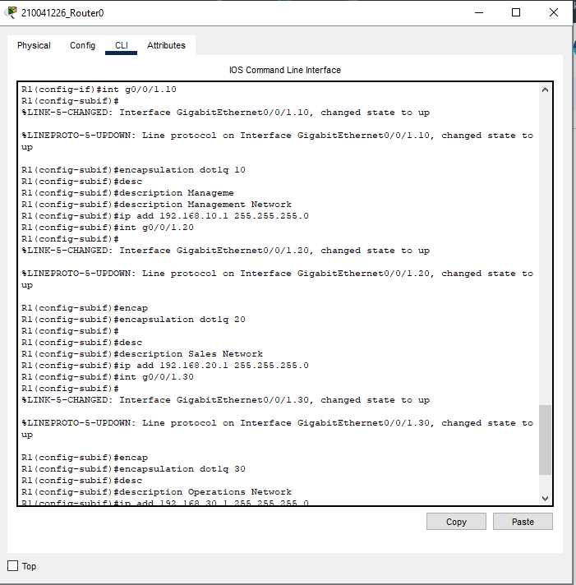
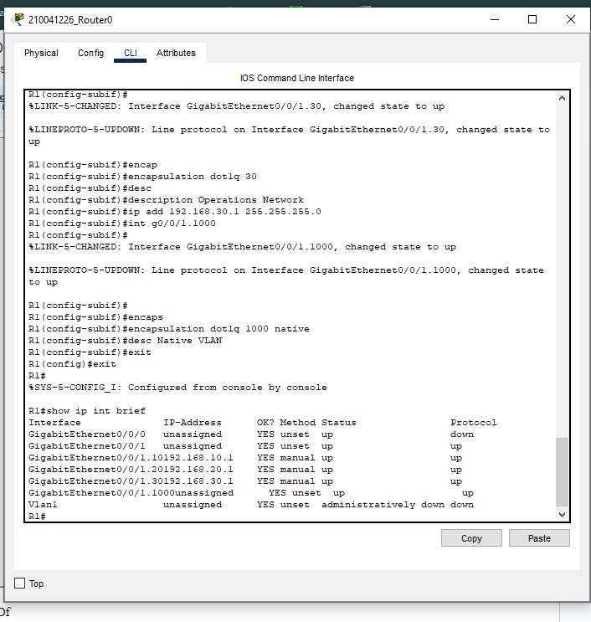

- After setting up the IP address of the PC different locations were pinged and they were successful

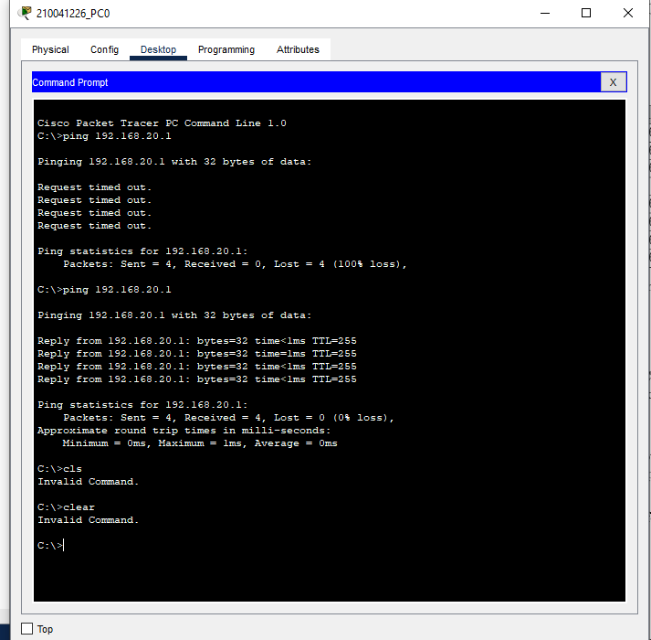
- 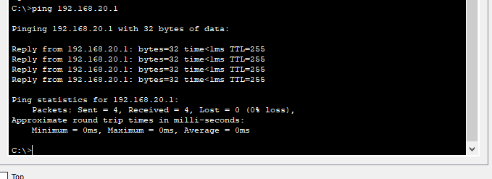

TASK #03:
- First calculated the subnet mask for all the departments and set the PC’s IP address and subnet masks
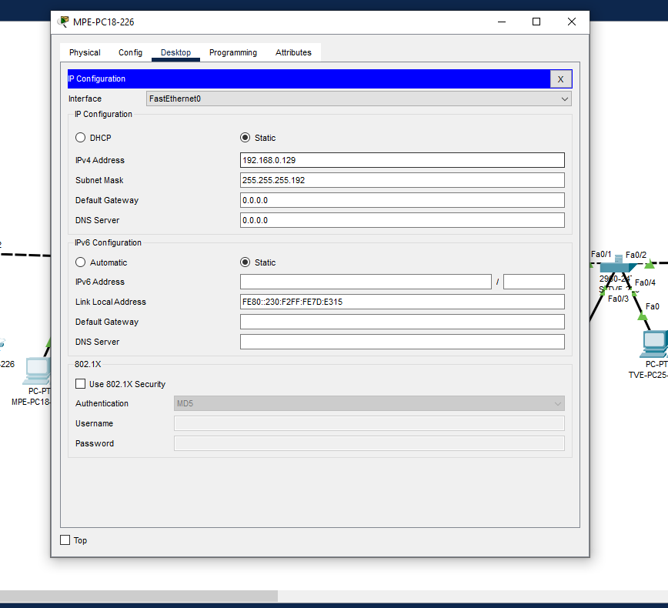

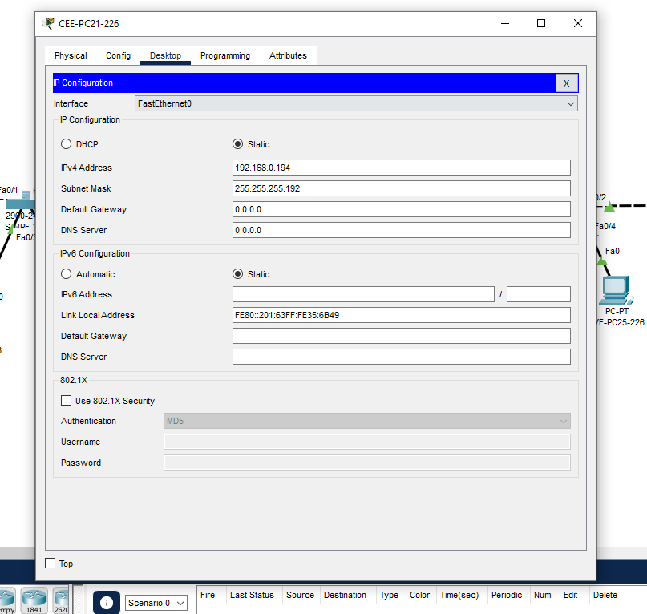
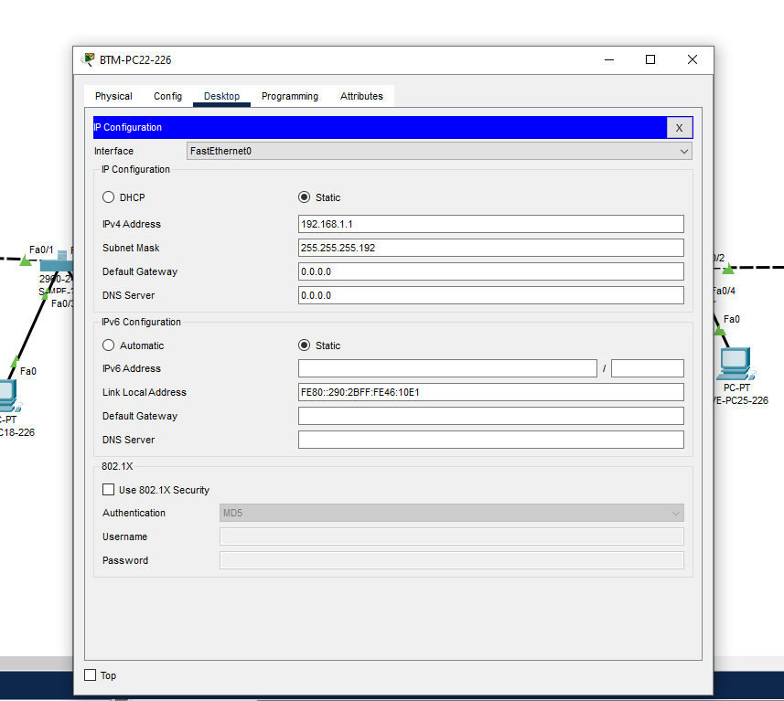
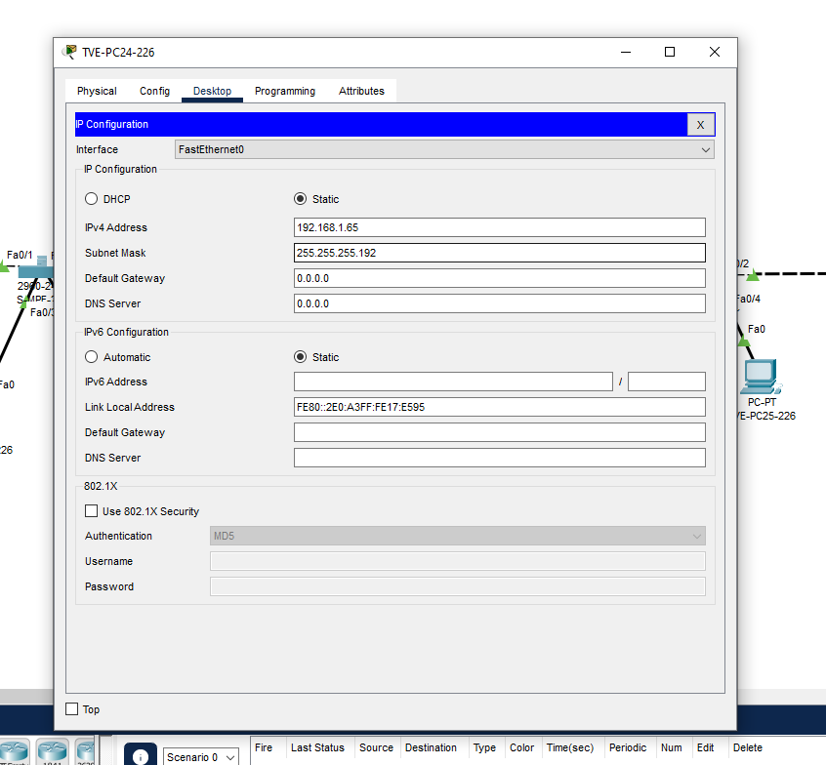
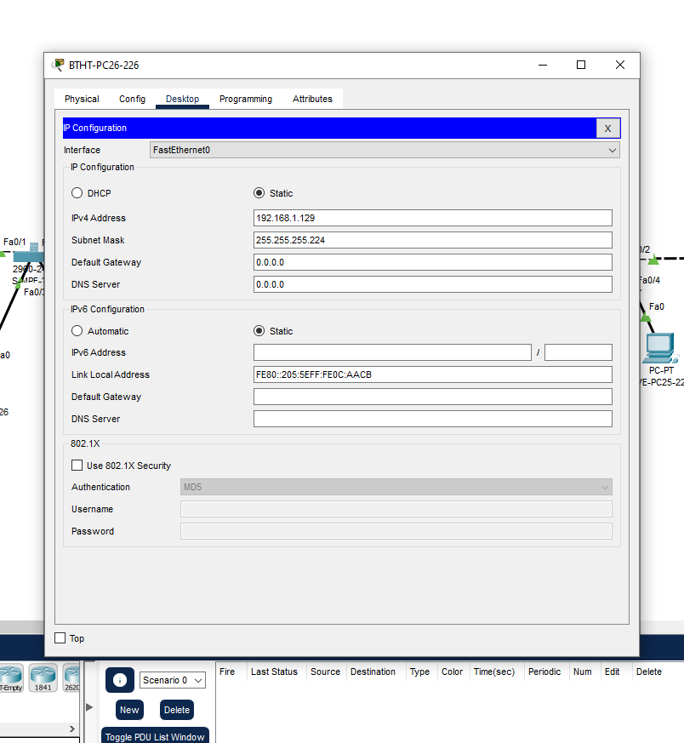
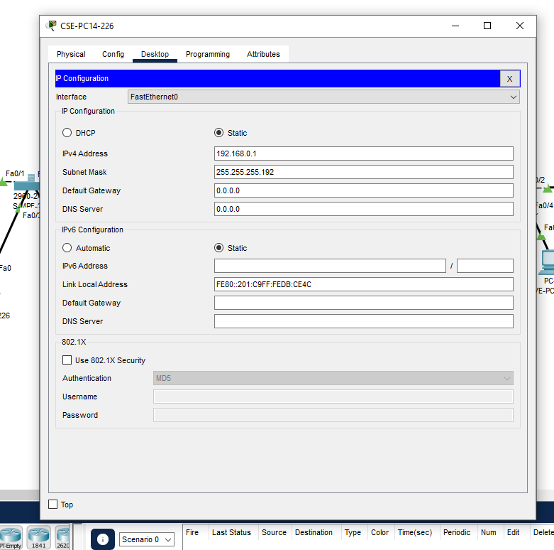
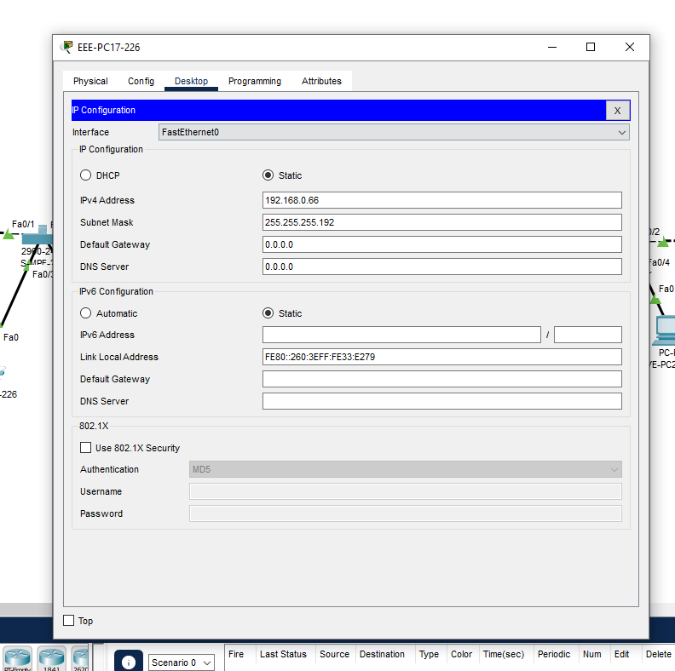

- Then configured the switches for all departments and the sub interfaces of the routers
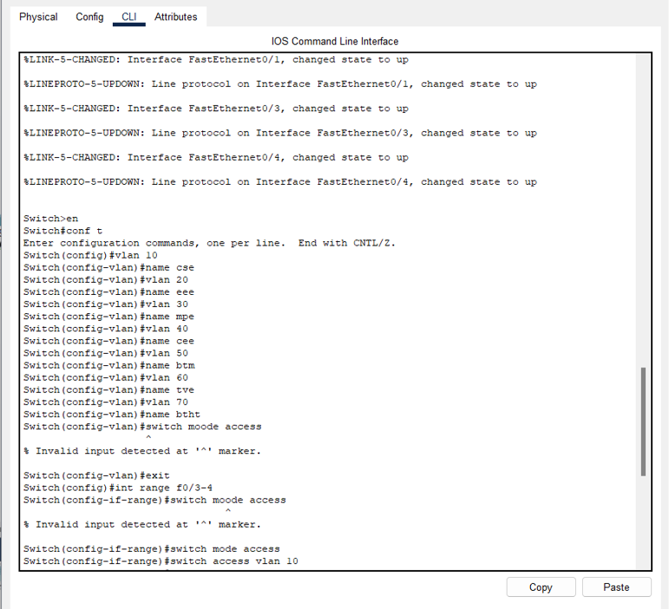
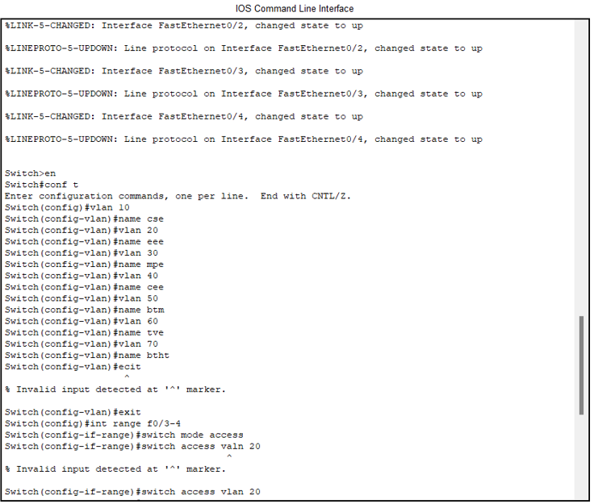
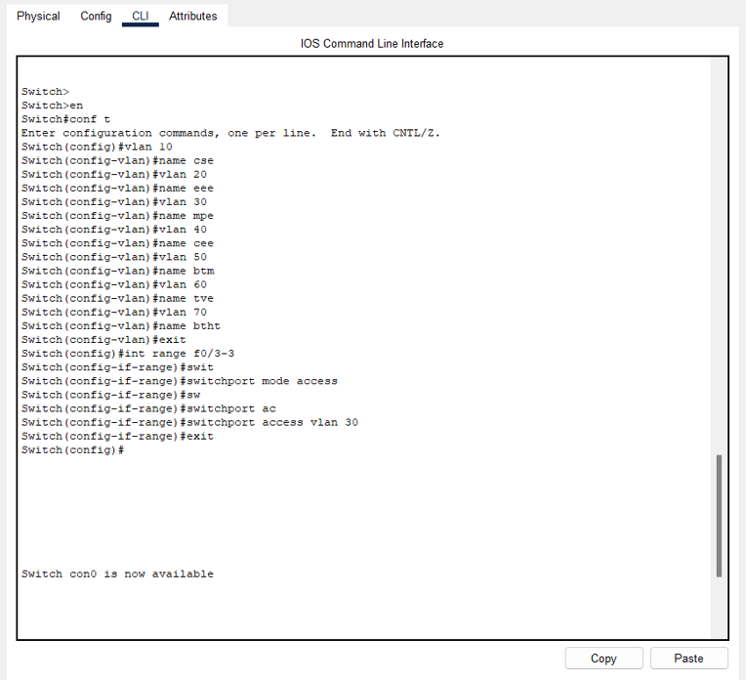
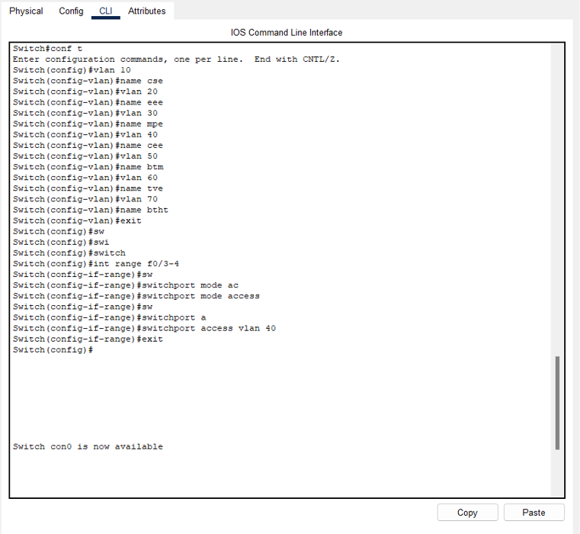
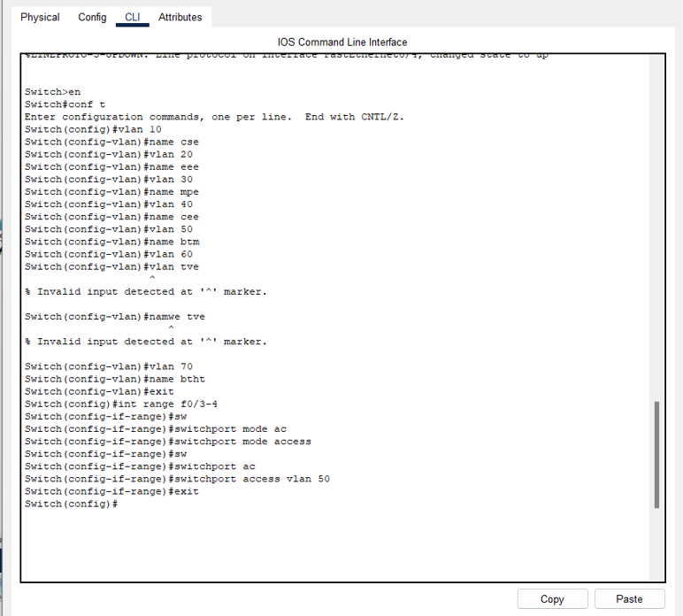
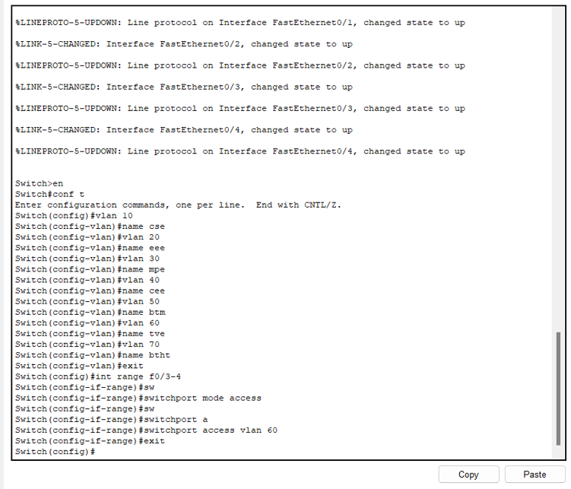

Observation:

- Task 1 was about how MLS performs the operations of both Layer 2 and 3 . Here we implemented inter VLAn communication
- Task 2 was about inter vlan routing by router on a stick method and Task 3 was about the same concept just more manual and practical

Challenges (if any):
- There were so many trial and errors
- Errors like native vlan mismatch was hard to debug
- Calculation difficulty in determining the subnet and the ip addresses of all the PCs
- There were also other difficulties in understanding the concepts of vlan and other theories necessary here

